|  |
| --- |
| 新东方在线英语学习 |
| 新概念 1 册 |
| Lesson27-28 |



扫一扫。更多有趣的英语资讯。

1. living room: 客厅
2. near: prep. 靠近、旁边电视靠近桌子。

The television near the table. The television is near the table.

1. window: 窗户
2. armchair: 扶手椅

arm 胳膊 + chair 椅子

1. door: 门
2. picture: 图画、照片
3. wall: 墙

the Great Wall 长城

# Lesson 27 单词讲解

**Lesson 27 课文讲解**

1. There is a television in the room.
2. There are some magazines on the… There is a + 单数名词…

There are some+ 复数名词…

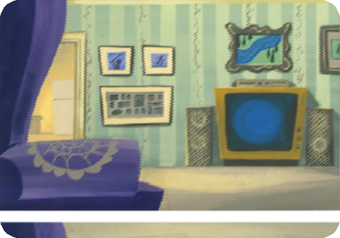

There is a sofa in the room. There is a television in the room.

There are some pictures on the wall.

# Lesson 27 语法讲解

1. 介词 prep.

介词：媒婆，连接两个词或词与句子。媒婆：on\ in\ of\ near

使用介词时，不能忘记动词！ 电视靠近窗户。

The television is near the window.

钱在包里。

The money is in the bag.

图片在墙上。

The picture is on the wall.

水在杯子里。

The water is in the glass.

1. trousers: 长 裤ˈtraʊzərz chuai ao zer zi

Pants pan zi

jeans 牛仔裤

shorts 短裤 shaoerzi

# Lesson 28 单词句型讲解

shoes\ socks\ gloves\ jeans\ pants\ glasses

Socks sa ke si

Gloves ge lou wuzi

# Lesson 27&28 知识拓展

有始有终

There is a beginning, a middle, and an end.

